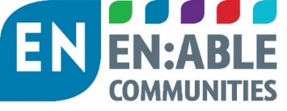

EN:Connect Employment and Skills in Communities Forum
#13
Tuesday 13 September 2022
14.00 -15.30

Venue Video meeting (MS Teams)

AGENDA

# | Time | Item | Presented by:
1 | 14.00 | Welcome  Introductions  Apologies | Simeon Perry Head of Operations  EN:Able Communities
2 | 14.05 | Case Study:  Thirteen Group  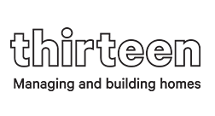 | Karen Kenmare  Head of Business Growth
3 | 14.30 | Social Housing supporting skills/ employment in the North East  Housing Employment Network North East (HENNE). What is HENNE, its background, future priorities, business plan  New Start Project: An employment project providing paid employment for over 25s | Ellie Patience Business Development Manager (HENNE)  Susanne Jobson Karbon Homes  Service User perspective: Laura Ramos – New Start supported employee - now working for EN:Able Communities
4 | 15.10 | National policy update:  Communities that Work  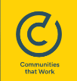 | Susanne Jobson  Board member of Communities that work (employed by Karbon Homes)
5 | 15.25 | Future meetings  - Topics to discuss  - Seeking landlords to present topics of their good practice | Simeon Perry
 | 15.30 | Close

