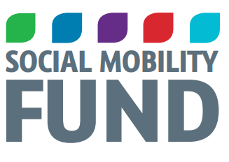
Application Form

PLEASE READ GUIDANCE NOTES BEFORE COMPLETING APPLICATION

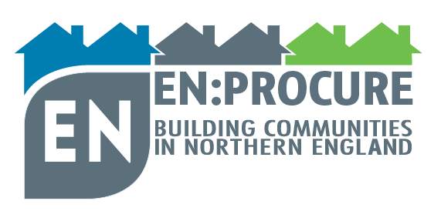

Application Form

- Organisation Details

1a. Organisation Name:
1b. Organisation Address:
1c. When was the Organisation established?

1d. Type of Organisation (see guidance notes)

1e. Please state the charity or company no. (if applicable)

1f. Website Address

- Applicant Contact Details

2a. Contact Name
2b. Position in organisation
2c. Contact Address
2d. Telephone Number
2e. Fax Number (if applicable)
2f. Email Address

- Project Details (where the prize money will be spent)
3a. Project Name1a) Project Name
3b. Project Location
3c. Estimated Project Start Date
3d. Estimated Project End Date

4a. Tell us about your organisation and how it has had an impact on the community in which it works (10 Marks)

In your answer please include information on ALL the following key points:
- Briefly describe your organisation
- What are its aims and objectives?
- What impact does the organisation have on the community in which it works?
- Identify an area / service, activity on which the prize monies would have a positive impact

(Maximum 500 words – box will expand).

4b. Describe how you will spend the prize money on your project (15 Marks)

Please include information on the following items, where appropriate:
- What you aim to achieve with the prize money
- How the project fits the theme of Social Mobility
- How the project will be delivered in the timescales (may wish to include a project plan as a separate appendix)
- Which sections within the local community the project will benefit
- How you will make people aware of your project
- How you will measure the success and impact of the project over its life-time
- How the project will be managed after completion, demonstrating the sustainability of the project and the long-term impact you hope to achieve

(Maximum 2000 words – box will expand).

5. What was your income in the last 12 months?

6. Bank Details

Bank Postal Address:

Organisation Account Number:
Sort Code:
Organisation Name (receiving the funding):
Contact Name:
Organisation payment address:
Email address:
Telephone number:

Should your organisation win one of the prizes, this information is needed for our payments department to release your funds promptly by BACS.

Declaration

I declare that any information given in this document is true and that any funds received would be solely used for this project.

I have completed this application and enclosed cost estimations for this project.

I have read the conditions related to winning this prize and agree to comply with them.

Applicant

Name:

Position in Organisation:

Date:

On Completion

This application, along with supporting documents, should be uploaded to the website – click here no later than the closing date Friday 8th October 2021

If you have any issues completing this application, please contact: Simeon Perry, Head of Operations EN:Able Communities CIO
Tel: 07884589122
E-mail: svteam@efficiencynorth.org

